Team Name - Dal Chawal
1. Atharva Kalekar - https://github.com/AtharvaKalekar/Campus-Sports-Ground-Booking-System-.git
2. Samarth Devadiga - https://github.com/SamarthD1/Campus_Sports_Ground_Booking_System-.git
3. Ameya Sagwekar - https://github.com/Ameya48/Campus-Sports-Ground-Booking-System-.git
4. Rizwan Salmani - https://github.com/Rizwan2611/Rizwan-Salmani
5. Sarang Gole - https://github.com/Saranggole9106/112_SARANG_GOLE

Campus Sports Ground Booking System Documentation

Introduction
This documentation details the Campus Sports Ground Booking System project: its requirements, technology stack, backend and frontend design, deployment, research plans, and reflections.

Phase 1: Survey
- Goal: Understand student & staff problems with booking.
- Example Questions:
  - How do you currently book the ground? (manual register / message / other)
  - What’s your biggest issue? (double booking / no availability / fairness / etc.)

  - What problems do you face while trying to book or access a ground?
  - Would you prefer an online system?

  - Which features would you like in a booking system?

- Expected Results:
  - Most students face unfair multiple bookings.
  - Everyone wants a transparent online portal.
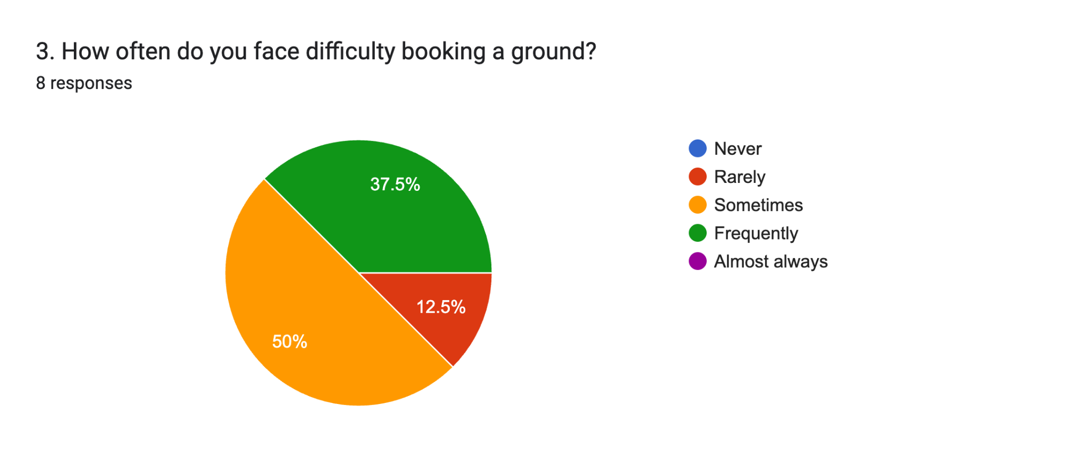
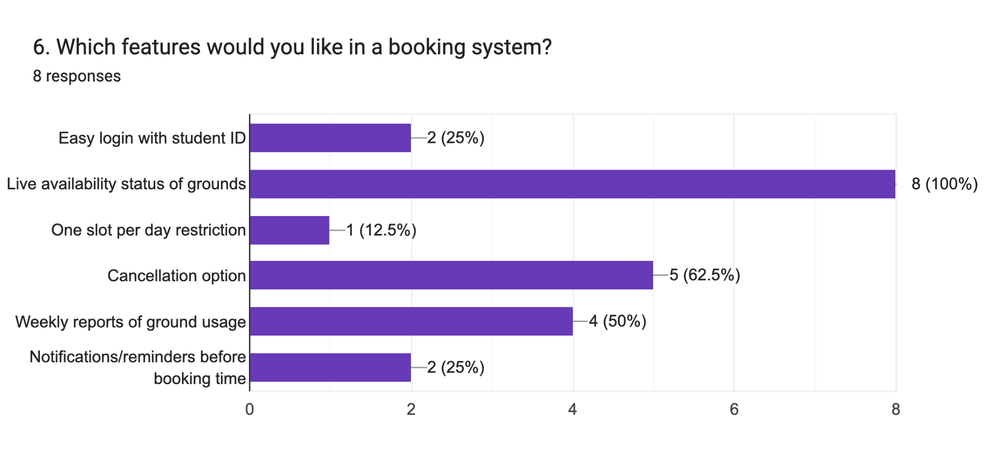

Phase 2: Case Study
- Case Chosen: Sports Ground Booking.
- Interviews:
  - Students → “I try to play football but seniors book multiple slots.”
  - Staff → “We write names in registers; sometimes two students claim the same slot.”

1. Current Workflow
At present, the booking of campus sports grounds is handled in a manual and unstructured way:
● Manual Registers: Students approach the Sports Office and write their names in a physical register for a time slot.
● WhatsApp/Verbal Requests: In some cases, bookings are done informally via WhatsApp groups or direct messages to the sports committee members.
● No Centralized Record: Records are either paper-based or scattered across different communication channels, making it difficult to track usage history.

2. Identified Pain Points
Through observation and discussion, the following issues were noted:
- Overlap Bookings:
Multiple students/groups end up booking the same slot for the same ground due to lack of a real-time system.
- No Transparency:
Students cannot see who has already booked a slot, leading to confusion and disputes.
- Misuse of Facility:
Some students book multiple slots in a single day, leaving less opportunity for others.
- Administrative Burden:
Sports committee staff spend considerable time manually updating and verifying registers.
- Lack of Notifications:
Students are not informed if their booking is confirmed, rejected, or cancelled.

3. Stakeholder Interviews

A. Student Users (End-Users)
● Feedback 1 (Student A):
“I often go to the football ground only to find out someone else has also claimed the same slot. It feels unfair and confusing.”
● Feedback 2 (Student B):
“It would be great if there was an app where we could see available slots in real-time and just book them.”
Key Needs Identified:
● Fair access (limit to one-slot-per-day).
● Transparency (see available slots before booking).
● Convenience (book online without visiting the office).

B. Sports Committee Staff (Administrators)
● Feedback 1 (Staff Member 1):
“We maintain a register, but students often argue if two names clash in the same time slot. It’s time-consuming for us to resolve.”
● Feedback 2 (Staff Member 2):
“Sometimes students book multiple slots in a single day. We have no effective way to stop this manually.”
Key Needs Identified:
● Automation of booking validation.
● Reduced disputes.
● Easy monitoring through a dashboard.

4. Conclusion & Insights
● Students want fairness, transparency, and convenience.
● Staff want automation, reduced workload, and proper monitoring.
● The main problem is the absence of a centralized, rule-based system.
● Solution Direction: A MongoDB-backed digital booking system enforcing “one-slot-per-student-per-day” with real-time updates and automated restrictions.

System Architecture
Architecture Overview:
- Backend: Node.js + Express with MongoDB for persistence.
- Frontend: React (or HTML/CSS/JavaScript) with Firebase Authentication and Firebase Hosting.

Phase 3: MongoDB Schema

- Database: MongoDB (flexible JSON-like).
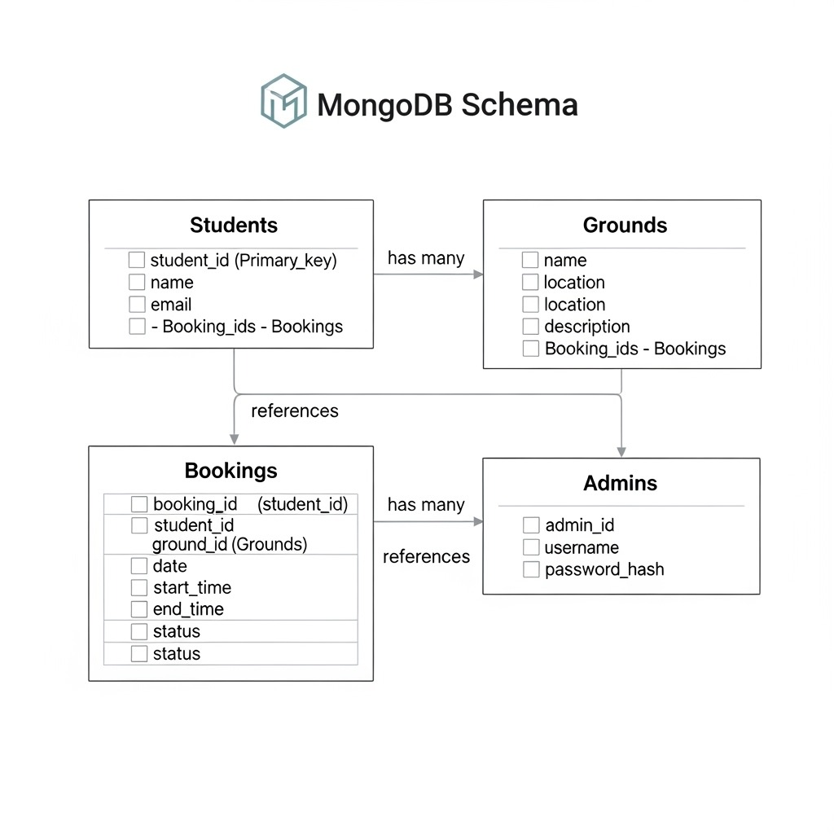

Students
- _id, name, email, rollNo, department
Example:
json
{
"_id": ObjectId("507f1f77bcf86cd799439011"),
"name": "Atharva Kalekar",
"email": "atharva@123.gmail.com”,
"rollNo": "CS2021001",
"department": "Computer Science",
"firebaseUID": "firebase_auth_uid_string",
"createdAt": ISODate("2024-01-15T10:30:00Z"),
"updatedAt": ISODate("2024-01-15T10:30:00Z")
}

Grounds
- _id, name, location, slots[]
Example:
json
{
"_id": ObjectId("507f1f77bcf86cd799439012"),
"name": "Football Ground",
"location": "North Campus Sports Complex",
"slots": [
"06:00-07:00",
"07:00-08:00",
"08:00-09:00",
"16:00-17:00",
"17:00-18:00",
"18:00-19:00",
"19:00-20:00"
],
"description": "Full-size football field with grass surface",
"capacity": 22,
"isActive": true,
"createdAt": ISODate("2024-01-15T10:30:00Z"),
"updatedAt": ISODate("2024-01-15T10:30:00Z")
}

Bookings
- _id, studentId, groundId, date, slot, status
Example:
json
{
"_id": ObjectId("507f1f77bcf86cd799439013"),
"studentId": "firebase_auth_uid_string",
"groundId": ObjectId("507f1f77bcf86cd799439012"),
"date": ISODate("2024-01-20T00:00:00Z"),
"slot": "16:00-17:00",
"status": "confirmed",
"bookingReference": "BK1705312345ABC",
"createdAt": ISODate("2024-01-15T10:30:00Z"),
"updatedAt": ISODate("2024-01-15T10:30:00Z")
}

Phase 4

Functional Requirements
- User Authentication
Students sign up and log in using Firebase Authentication (via email/password or Google login).
  - Each logged-in student is mapped to a record in the Students collection in MongoDB.
- Booking System
Students select a ground, date, and time slot.
  - Before confirming, the system checks MongoDB to ensure:
    - The slot is available.
    - The student hasn’t already booked for that date (restriction rule).
- Real-Time Updates
  - Bookings are synced using Firebase Realtime Database or Firestore.
  - If a slot gets filled, other students immediately see it as unavailable.
- Dashboard
  - Students → can view their upcoming bookings.
  - Admins → can view all bookings for all grounds and cancel/approve if needed.
- Deployment
  - Frontend + prototype deployed on Firebase Hosting.
  - MongoDB stores booking data permanently.

Roles
- Authentication - Rizwan
- Database - Sarang
- JS Code - Ameya, Atharva, Samarth
- Schema - Atharva & Ameya
- Survey - Atharva
- Documentation - Ameya
- Case Study - Samarth & Rizwan

Challenges / ERRORS faced
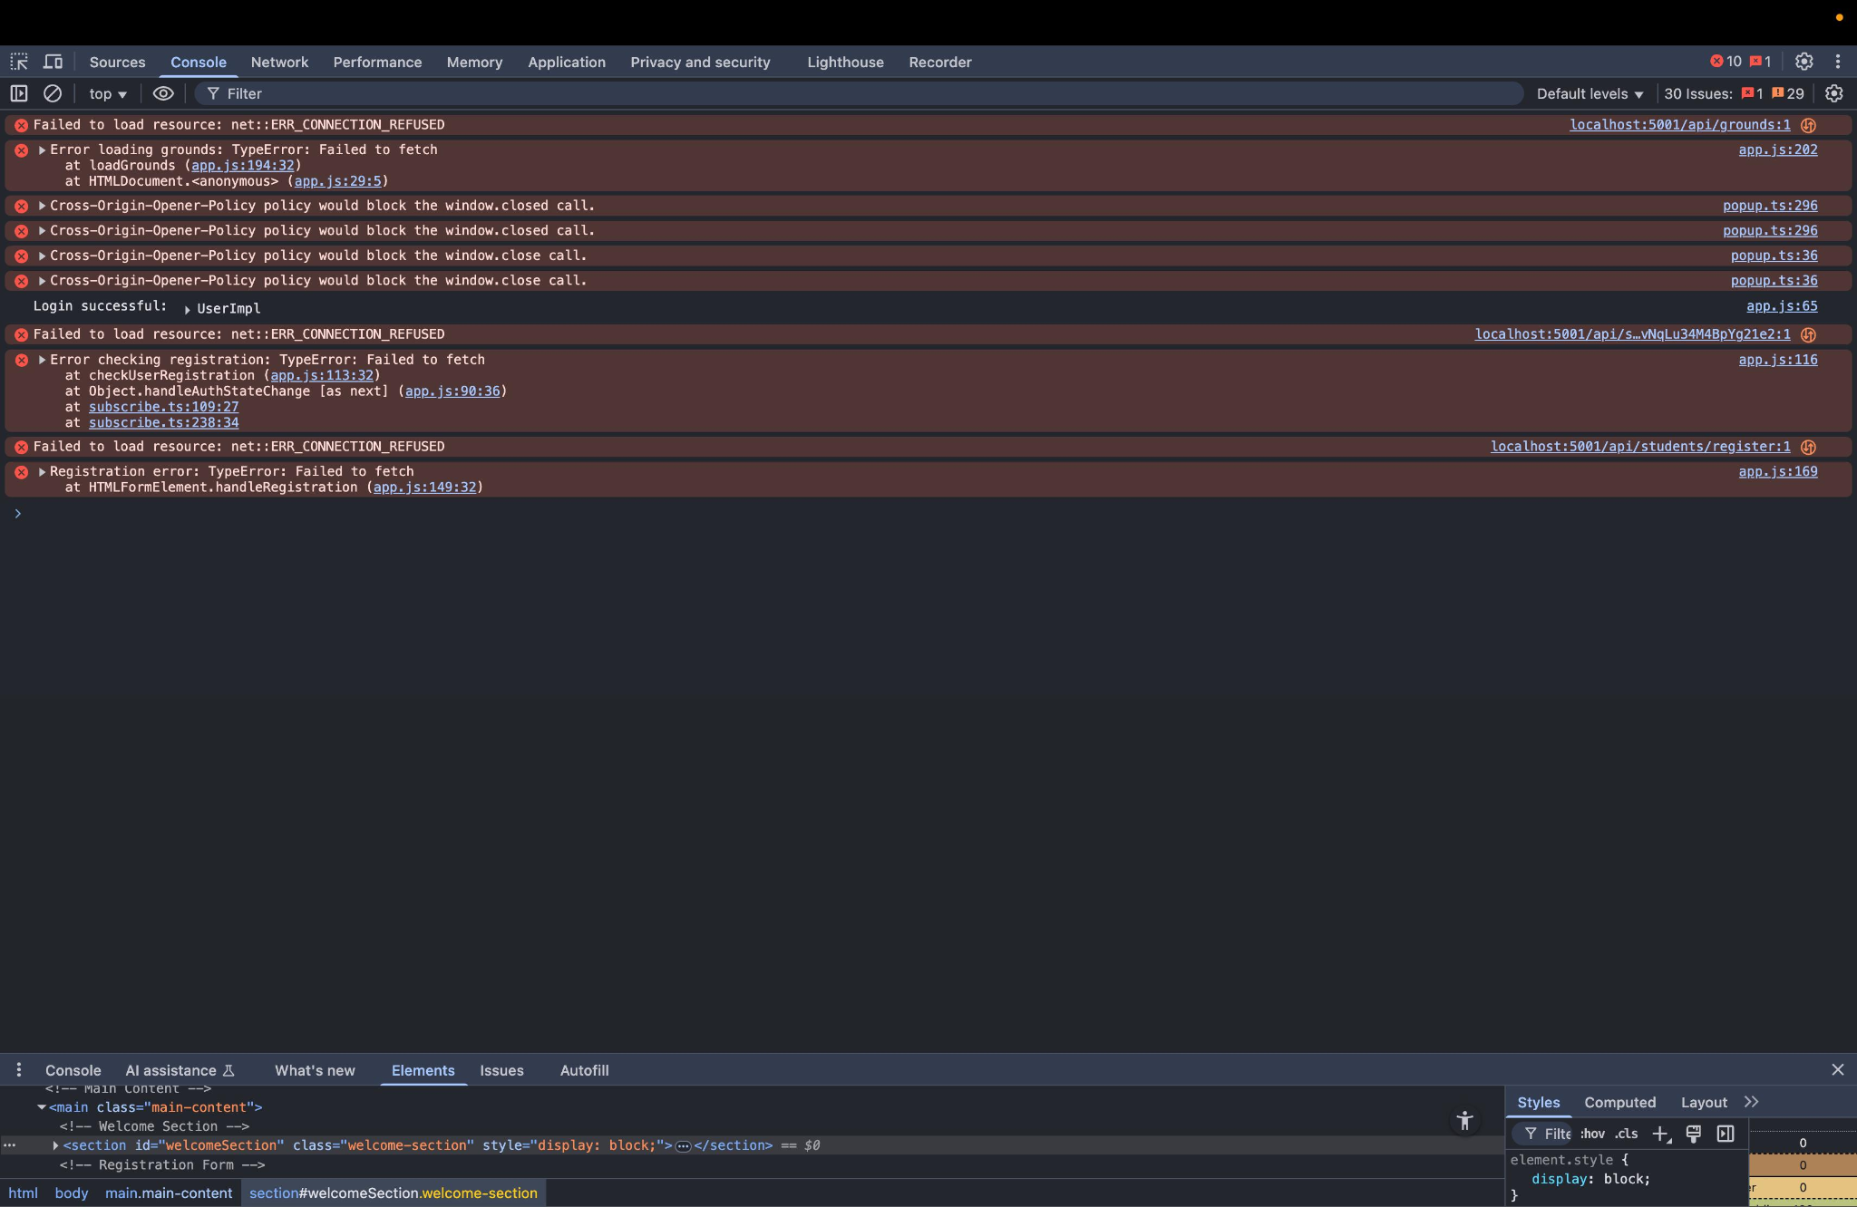

Errors
- Failed to load resource: net::ERR_CONNECTION_REFUSED
- TypeError: Failed to fetch
- Cross-Origin-Opener-Policy warnings
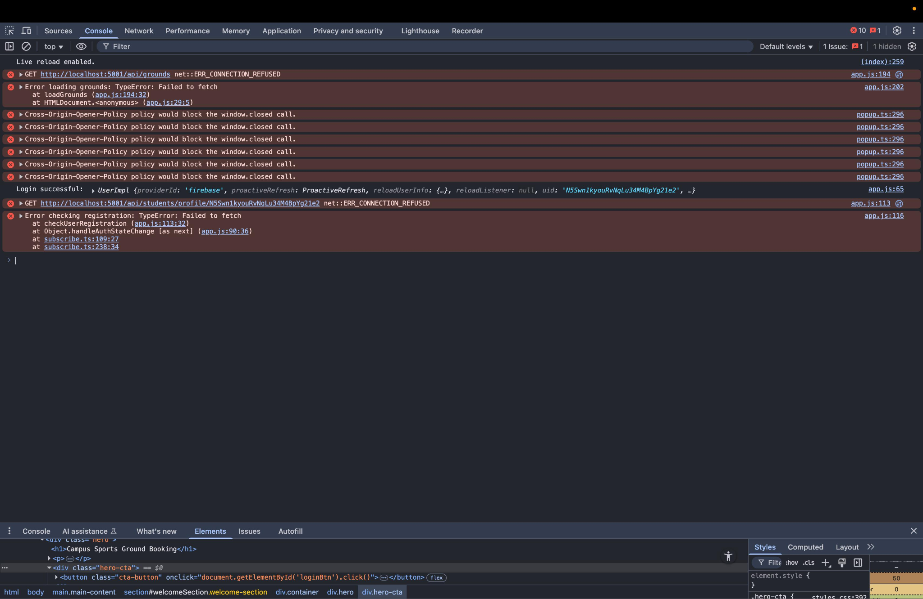

Error
- GET http://localhost:5001/api/grounds net::ERR_CONNECTION_REFUSED
- GET http://localhost:5001/api/students/profile/... net::ERR_CONNECTION_REFUSED
- Cross-Origin-Opener-Policy warnings
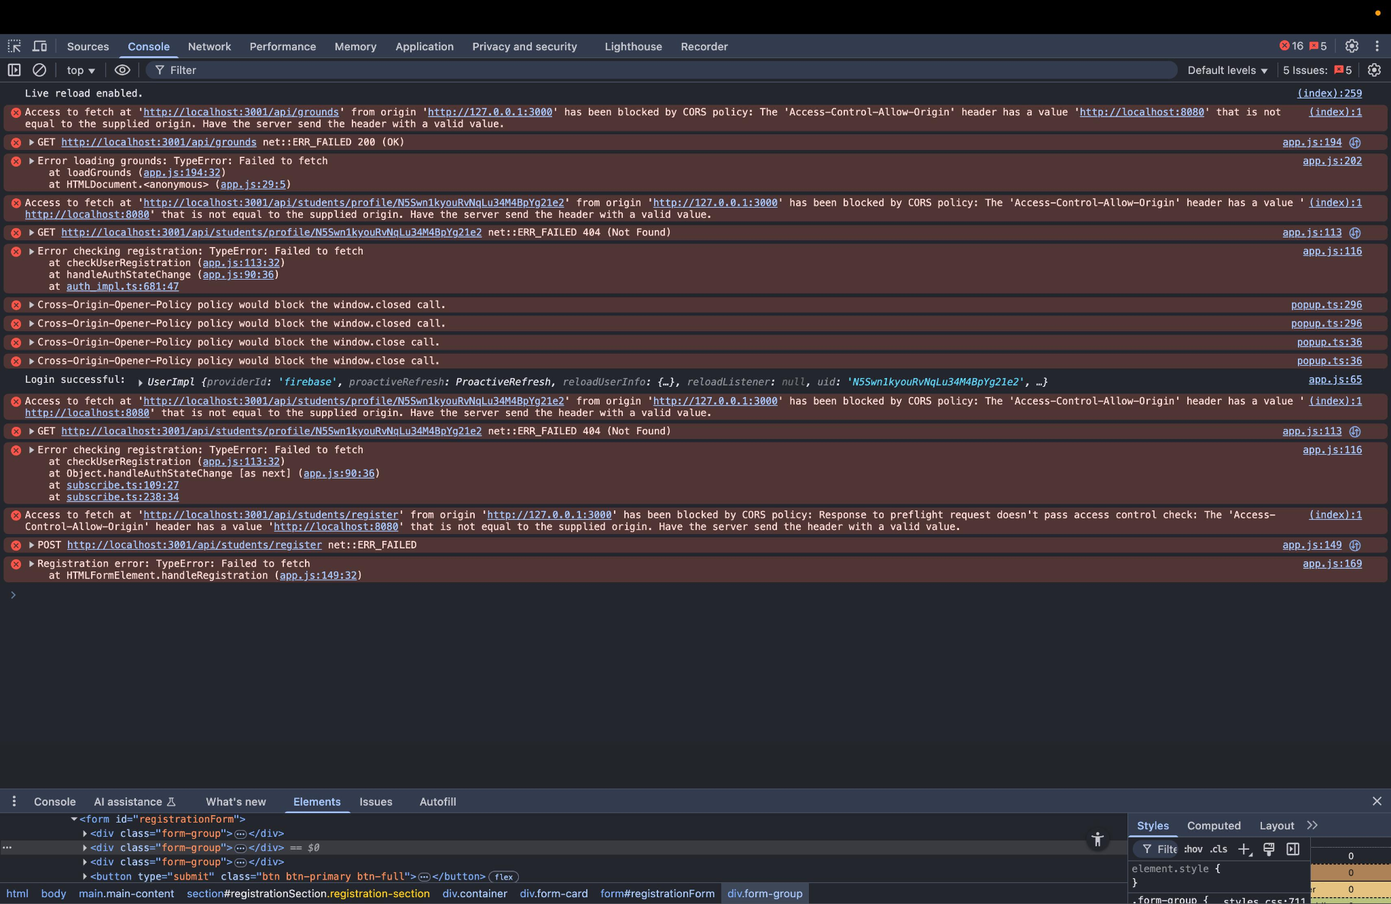

Errors
- CORS Policy Error
- 404 (Not Found) Error
- CORS Preflight Error (for POST)

References
- Google Docs API documentation
- Software project report examples

